**TASK 2**  NAME:____ANSWERS________

**ATAR CHEMISTRY UNITS 1 & 2 SCIENCE INQUIRY 1 QUIZ**

TOTAL 20 marks

1. Define the word isotope. (1 mark)

**An element with the same number of protons but a different number of neutrons**

2. A natural sample of copper contains two different isotopes. The major isotope,

copper-63 has a relative atomic mass of 62.9 and comprises 69.2% of the atoms in

the sample. The remaining 30.8% of the atoms are copper-65 with a relative atomic

of 64.9. Determine the average relative atomic mass of naturally occurring copper.

(2 marks)

**Ar = (62.9 x 69.2) + (64.9 x 30.8)**

**100**

**= 63.5**

**Working 1 mark**

**Answer 1 mark**

The data below is for an unknown element.

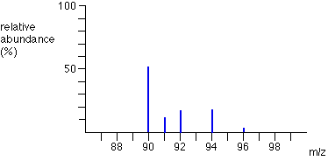

3. Calculate the average relative atomic mass of this element and use your periodic table to identify this element. Show all your working. (3 marks)

**Ar = (90 x 51.5) + (91 x 11.2) + (92 x 17.1) + (94 x 17.4) + (96 x 2.8)**

**100**

**= 91.3**

**Zirconium (Zr)**

Note : accept Niobium (Nb)

+ or – 1 (90.3-92.3)

or

any other justified answer

**Working 1 mark**

**Value 1 mark**

**Answer 1 mark**

4. Draw a flow diagram showing the key steps involved in using a mass spectrometer. Explain each of these steps in detail. (10 marks)

**Flow diagram (1 mark)**

**Vaporisation ➔ Ionisation ➔ Acceleration ➔ Detection**

**Explanation**

**(max of 9 marks from the points below but must cover all steps)**

**Vaporisation**

* **Unknown element heated to form a gas**

**Ionisation**

* **Gas atoms are bombarded with high energy electrons**
* **Gas atoms lose their electrons**
* **Form positive ions**

**Acceleration**

* **Ions are attracted to negatively charged plated/pass through electric field**
* **Ions accelerate**
* **Ions pass through a curved tube placed in a magnetic field**
* **Heavier ions get deflected less**

**Detection**

* **The isotopic mass is calculated**
* **The relative abundance is calculated**